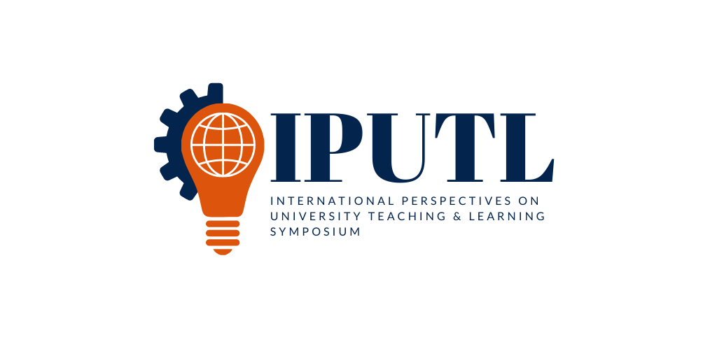

**Registration open and accepting proposals for 2021 International Perspectives on University Teaching and Learning Symposium**

AUBURN, Ala. – The Auburn University Office of International Programs will host the third International Perspectives on University Teaching and Learning Symposium June 2-4, 2021 at Disney’s Grand Floridian Resort and Spa in Orlando, Florida, a fitting international location for the 2021 ‘Geared for Global’ theme. IPUTL 2021 is also offering a discounted online option for those who cannot or do not wish to attend in person. Using an intimate and dynamic environment, the symposium encourages the collaboration of a diverse collection of global thinkers who are geared toward creating and sustaining an internationalized campus culture across higher education institutions.

Proposals for conversation starter essays, pre-conference workshops and concurrent sessions should be submitted to the symposium website ([www.auburn.edu/international/iputl](http://www.auburn.edu/international/iputl)) by March 15. Also, there is a call for proposals for a special edition of Wiley Publishing’s journal “New Directions for Teaching and Learning” that can be submitted to the website until March 15 as well. The journal will be a companion to the symposium, and it is expected that some presentations at the symposium will be selected for publication in addition to those selected through website submission. The special volume will present international perspectives on critical issues impacting teaching and learning in a diverse range of higher education environments. Desired proposal topics include international collaborations in teaching and learning, global innovations in teaching, the multicultural classroom, creative uses of technology, internationalizing the curriculum and other relevant subjects geared toward internationalization.

Early-bird in-person registration is $650 until April 1, after which the price increases to $700. Online registration is $250 now until the close of registration on May 14. Also, if there is a change of plans and an in-person registrant wishes to switch to the online option, a refund totaling the cost difference will be provided up until May 14. In-person registration includes all workshops; the opening dinner and reception at Epcot; all symposium sessions and breakfast; lunch and break snacks on June 3-4. The online option covers the cost of technology to provide the same symposium experiences virtually, without the cost of food.

Lastly, the hotel is offering steeply discounted rates for in-person symposium attendees, which can be accessed here (<https://www.mydisneygroup.com/auburnuniversitysymposium2021/places-to-stay#Disneys-Grand-Floridian-Resort--Spa>). Masks will be required at all times for in-person attendees. Physical distancing and enhanced cleaning protocols will also be in place to create the safest possible environment. Review the full description of Disney’s policies here (<https://disneyworld.disney.go.com/experience-updates/>).

To submit a proposal and register for the symposium, please visit the website ([www.auburn.edu/international/iputl](http://www.auburn.edu/international/iputl)). For questions or to be added to the e-newsletter contact list, email [iputl@auburn.edu](mailto:iputl@auburn.edu).